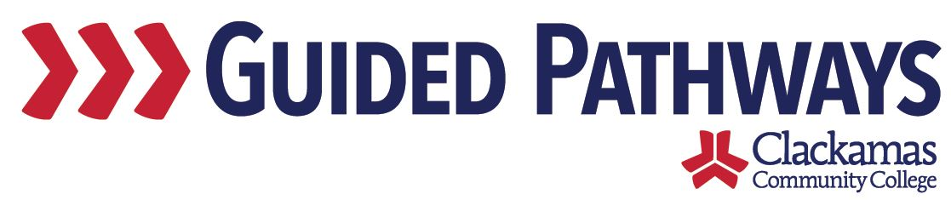
Guided Pathways Leadership Taskforce
Meeting Notes
August 3, 2020, 2:00–3:30 p.m. (Zoom)

- Follow up on previous commitments and updates
- Kelly compiled the changes to the self-assessment – sent out a few weeks ago (see attached document below)

- Review Self-Assessment and Determine Finish Line
- Max shared the completed self-assessment on the screen
- Max highlighted the changes in the document, discussed the progress to date and next steps that were added
- At what point are we comfortable with saying we are doing most of these best practices and we’re comfortable with the GPTF going away?
- Thoughts/feedback:
  - Are we improving student outcomes?
  - Taskforce should continue to exist to examine results and ensure we are meeting our goals?
  - Lisa Anh has a meeting planned in the fall to align outcomes between SEM, DEI, and guided pathways
  - Dustin discussed the ones listed as “not occurring” – change to “not systematic” since we haven’t made a decision not to do those things
- Are there core areas we want to monitor and make sure we get to as a taskforce? Are there any of these that we are planning on not completing fully?
  - Homework for the next meeting?
  - Some sort of rubric to frame thinking, provide consistent lens

Commitments:
- Kelly and Max to put their heads together this week and email homework assignment for September meeting

- Discuss GPTF Charter
- What do we really want to be achieving? What is our purpose? What are we trying to deliver?
- Charter draft – start thinking about charge and mission
- The taskforce broke out into three groups – each working on a draft section
  - Group 1 (Jaime, Jennifer, Tara): charge
  - Group 2 (Dustin, Lisa, Lori): specific project deliverables
  - Group 3 (Melissa, Nora, Sue): desired results
- Lisa pointed out that the homework we do for the next meeting might help to inform this – until we have that conversation, this might be constrained – Kelly agreed, said that this is intended to be a way to start that conversation and get our brains working
- Report out:
  - Group 1 (Jaime, Jennifer, Tara): charge
    - Talked about creating a plan of work for guided pathways ensuring inclusivity and identifying barriers to success, coordinating and evaluating our efforts, engaging our campus, external workgroups
    - Is this a decision making body? Is it an advisory group? Who are we to each other? Who do we report to? Who do we share our ideas with?
  - Group 2 (Dustin, Lisa, Lori): project deliverables
    - Stuck on needing to do the homework first to know what the deliverables are – what is the focus of the group? Which of the things in column A are we going to get to scale and which aren’t we going to do?
    - There are some elements that could potentially be important, but would we want to establish those as a deliverable (for example: students taking courses when they need them) – wanted to tie that back to the self-assessment as much as possible
  - Group 3 (Melissa, Nora, Sue): desired results
    - Best practice scaling, achieve indicator targets, see improved communication and shared governance around guided pathways, want to have more integration of functions around guided pathways, reduction of silos, reorg be informed by guided pathways, improved student experience (measured by EYES survey results)
    - Desired result is that the work of guided pathways is embedded in the work of the college
- Kelly asked the groups to send their notes to her

- Review 2020-2021 Priorities and Membership
- Max shared the project inventory Google Doc on the screen
- Combined projects into different categories – EFA development, EFA support, FYFE, pre-college, scheduling, student learning
- Wanted to talk about priorities within the boundaries of the categories
- Go category by category – for each category, everything above this number is a high priority, everything in this range is a medium priority, and everything below this number is a low priority
- Max made updates to the Google Doc – Kelly made some notes

- Review commitments and next steps
- Commitments and next steps were reviewed
- The next meeting of the Guided Pathways Taskforce is on Monday, September 7, 2:00-3:30 p.m.

